Cmd: nmap 192.168.1.1
Purpose : Scans the most common TCP ports on the target IP address to identify open ports and determine which network services may be accessible on the device.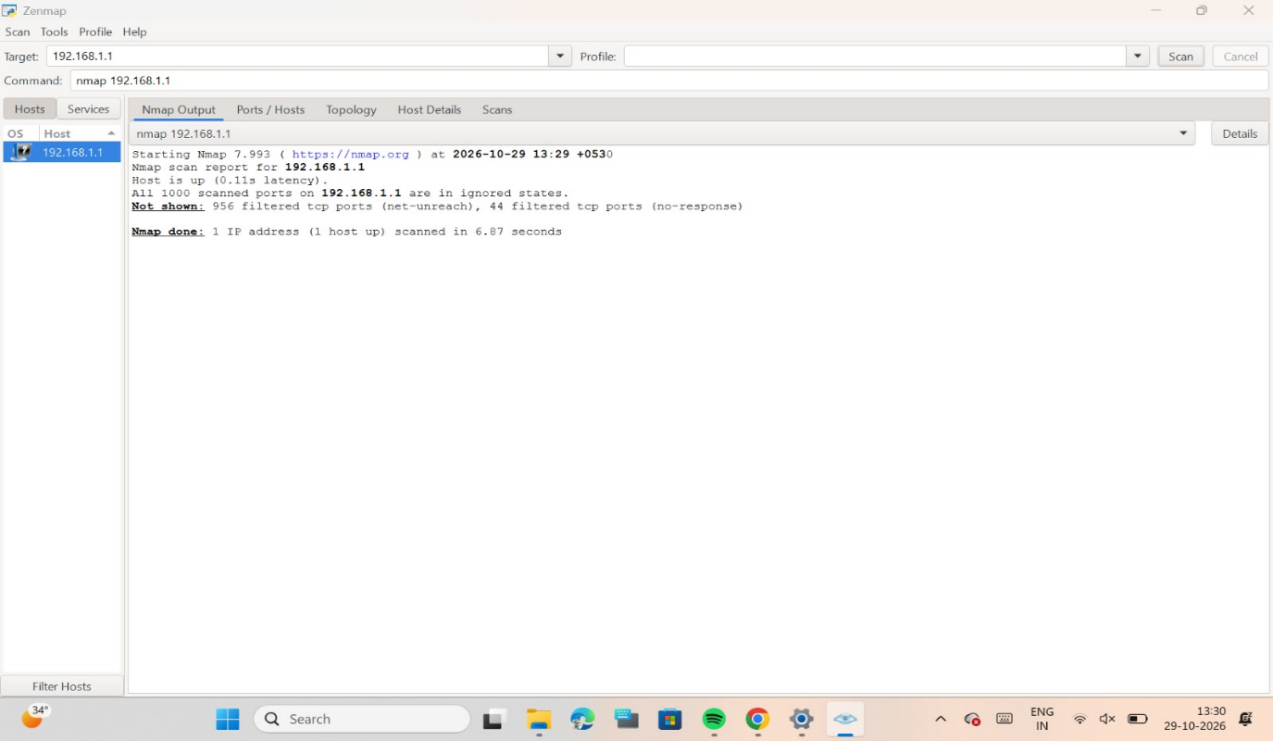

Cmd: nmap -sn 192.168.1.0/24
Purpose: Performs a host discovery scan to identify active devices on the local network. It checks the specified subnet to determine which IP addresses appear to be reachable without performing a port scan.
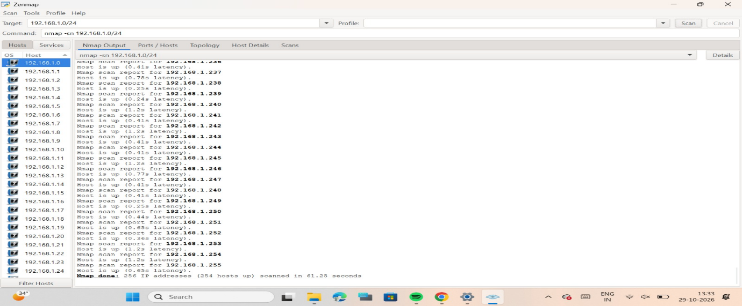

Cmd: nmap -sV 192.168.1.1
Purpose: Detects the services running on open ports and attempts to identify their software names and version numbers. This helps administrators identify outdated services and potential security vulnerabilities.
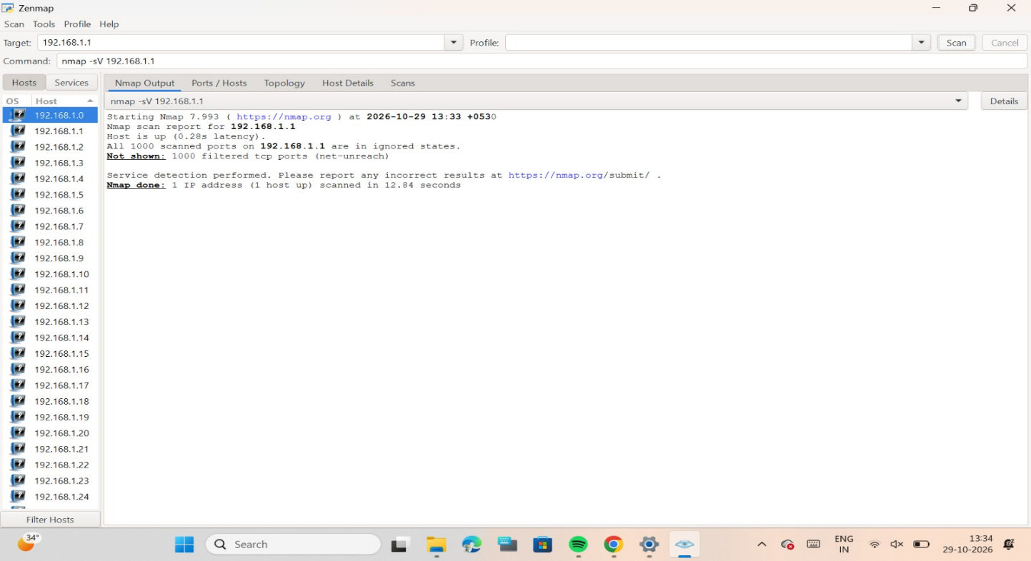
Cmd : nmap -O 192.168.1.1
Purpose : Attempts to identify the operating system running on the target device by analyzing network responses. This helps determine whether the device may be running Windows, Linux or another operating system.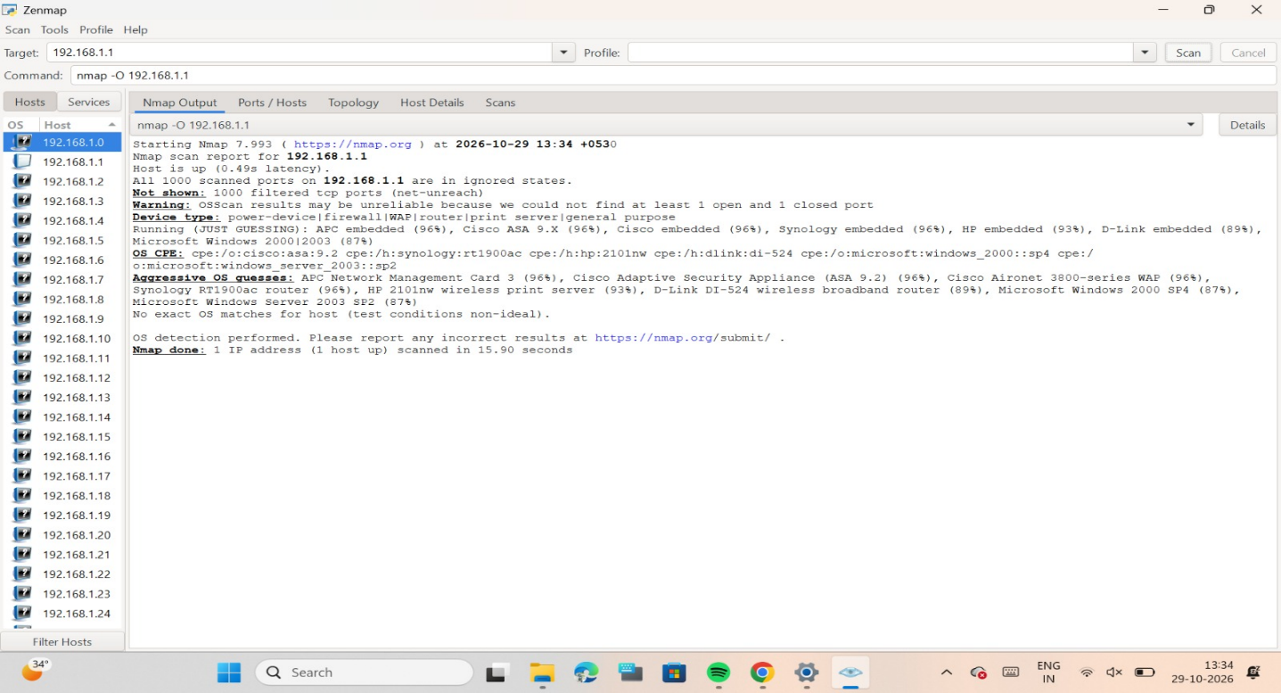,

Cmd : nmap -p 80,443 192.168.1.1
Purpose: Scans only ports 80 and 443 on the target device. Port 80 is commonly used for HTTP web traffic, while port 443 is used for HTTPS encrypted web traffic.
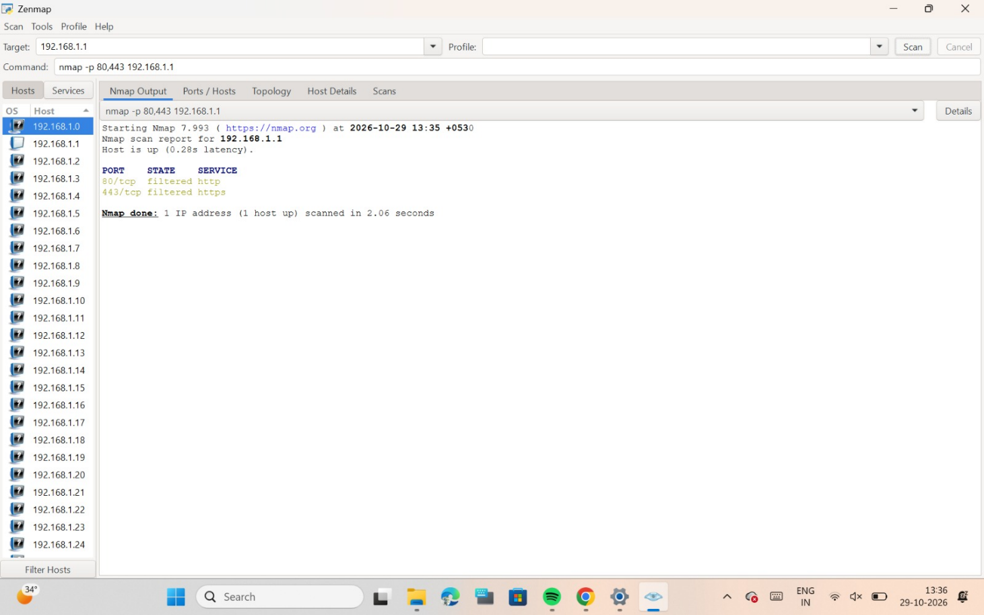
Cmd : nmap -sC 192.168.1.1
Purpose: Executes Nmap's default set of NSE (Nmap Scripting Engine) scripts to collect additional information about the target, such as service details and certain configuration issues.
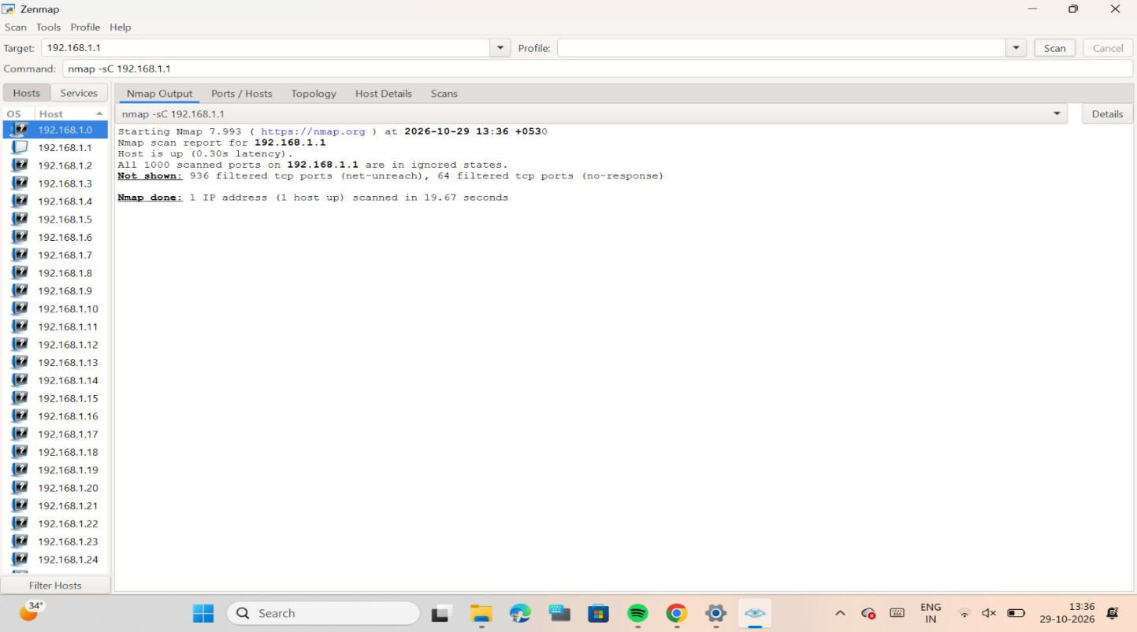

Cmd : nmap -Pn 192.168.1.1
Purpose: Skips the normal host discovery process and treats the target as online. Nmap then attempts to scan the target's ports even if it does not respond to preliminary discovery probes.
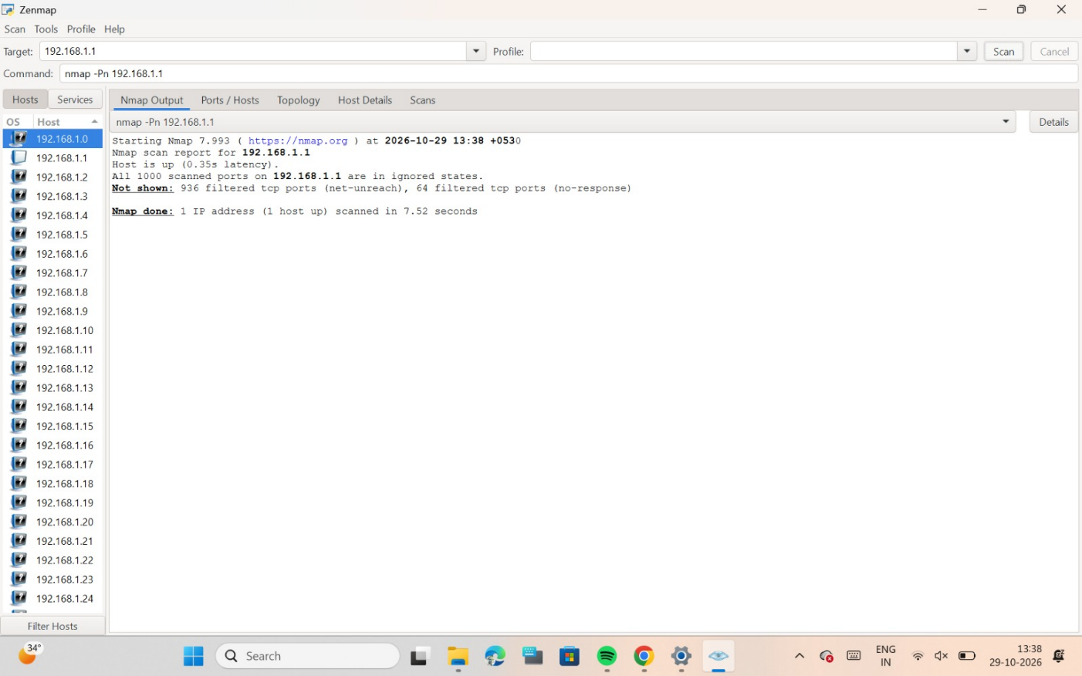
Cmd: nmap -oN scan.txt 192.168.1.1
Purpose: Saves the scan output in normal, human-readable text format to a file named scan.txt. The saved report can be opened later for documentation, analysis, and practical lab records.

